ELECTRONIC PACKAGing

PROJEC**T -** END EVALUATION

Date:21/11/2022

# Overview

## PROBLEM STATEMENT:

Maximum power point tracker (MPPT) solar charge controller using Lt3652

## Project Scope

|  |  |
| --- | --- |
|  | * To charge a battery with a solar panel, the most popular choice is the **MPPT or maximum power point tracker** topology. * Because it provides much better accuracy than other methods like PWM controlled chargers. * MPPT gives its best efforts to charger the battery, even sunlight is poor. The charge controller measure output voltage and battery voltage. Then it decides the best power from the above conditions. * The **MPPT Charge controller circuit**that we design in this project will have the following specifications: * It will charge a 2P2S battery (6.4-8.4V) * Charge current will be 600mA * It will have an additional charging option using an adapter. |

## Requirements

|  |  |
| --- | --- |
|  | Components required to build the project |

The new system must include the following:

* LT3652 Driver
* 1N5819 - 3 pcs
* Capacitors
* LED
* Inductor
* Battery - 7.4V
* Resistors
* Barrel socket

## Working process

|  |  |
| --- | --- |
|  | Complete work process of making Schematic and PCB layout. |

* We completed the solar charge controller circuit in eagle software. It is the schematic diagram of the problem we are working on.
* For this we have installed LT3652 library to complete this schematic.
* We have designed 3 PCB layouts for the same schematic to achieve the compact version of the layout with minimal VIA’s

## Schematic Circuit using LT3652

|  |  |
| --- | --- |
|  | The screen shot of the schematic file. |

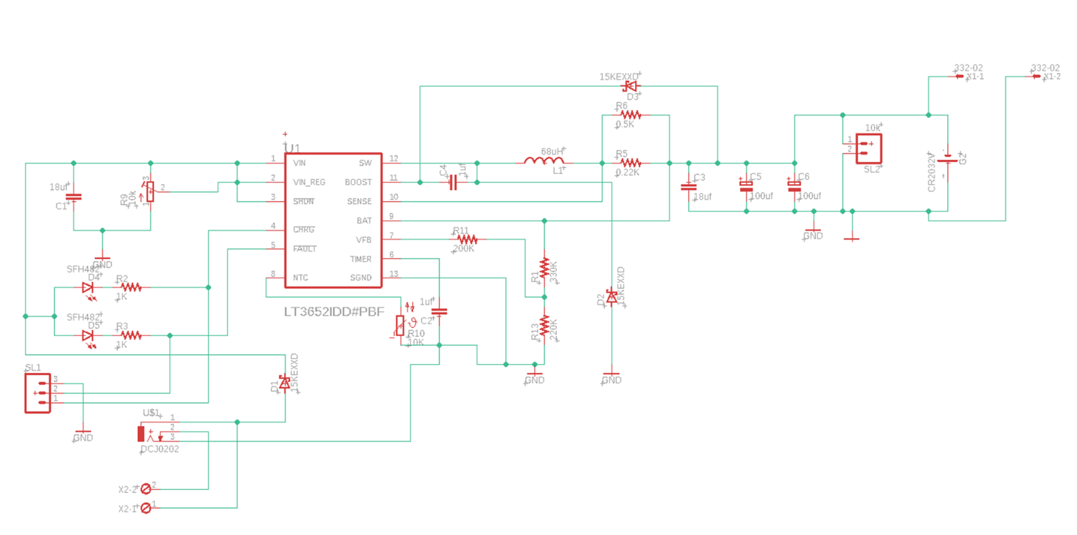

## PCB LAYOUTS

|  |  |
| --- | --- |
|  | The screen shot of 3 different PCB Layouts |

**PCB Layout 1**

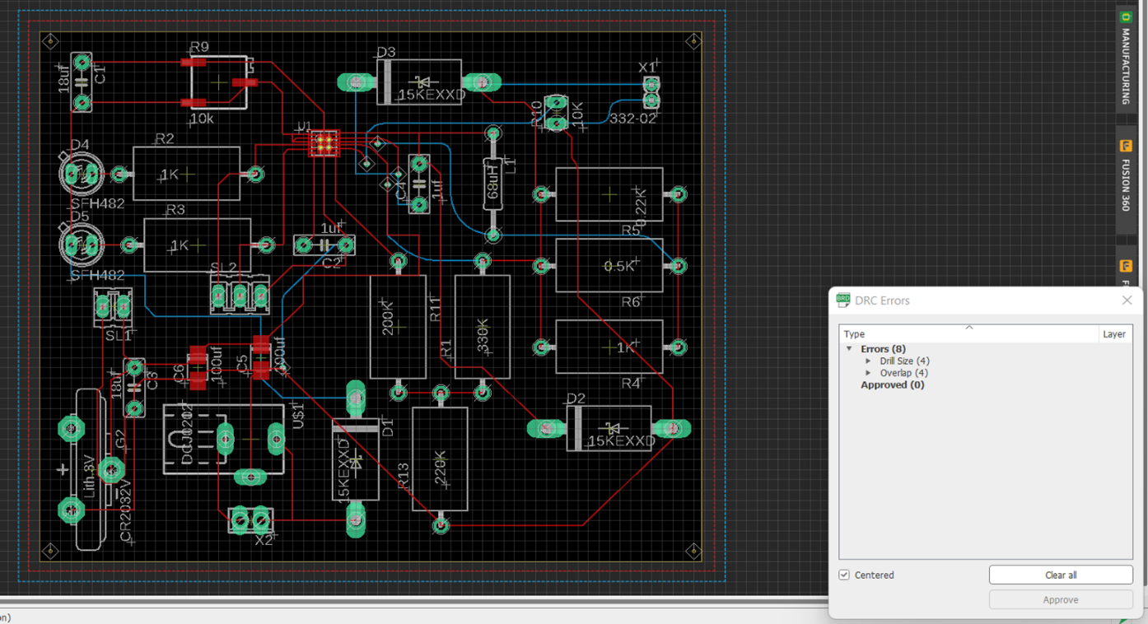

**Top Layer**

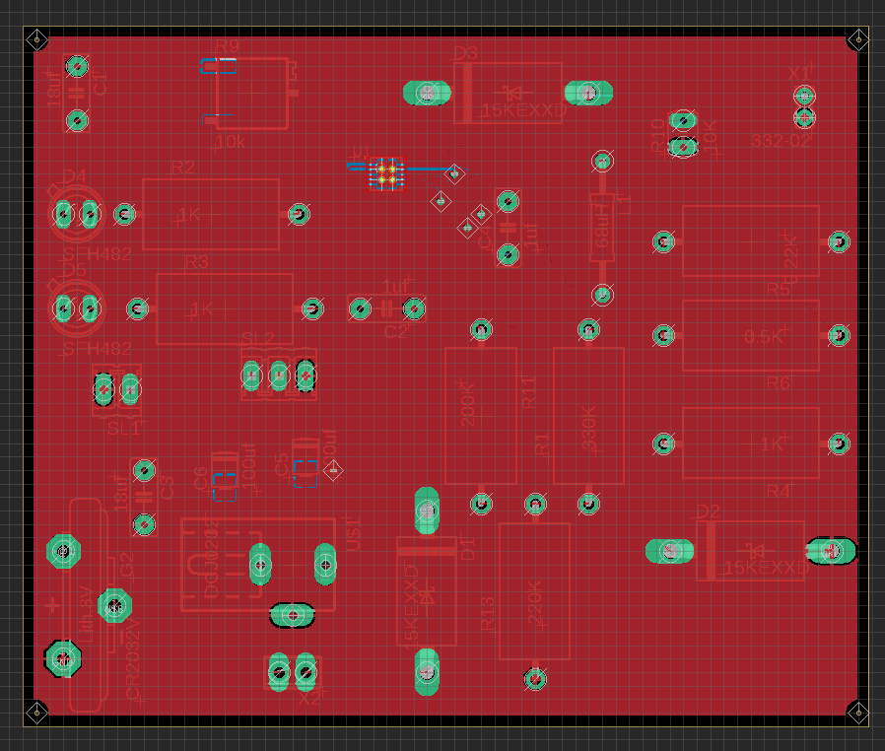

**Bottom Layer**

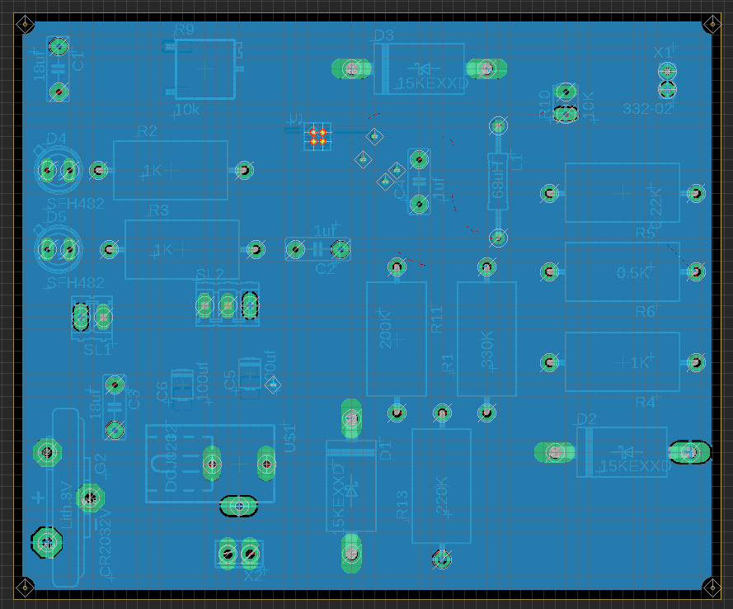

**TOP VIEW**

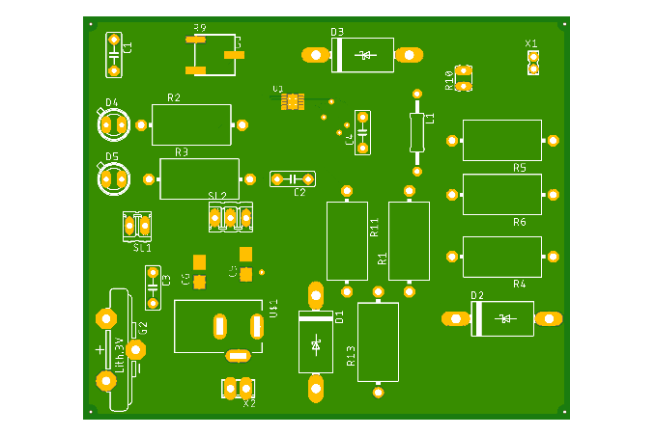

**BOTTOM VIEW**

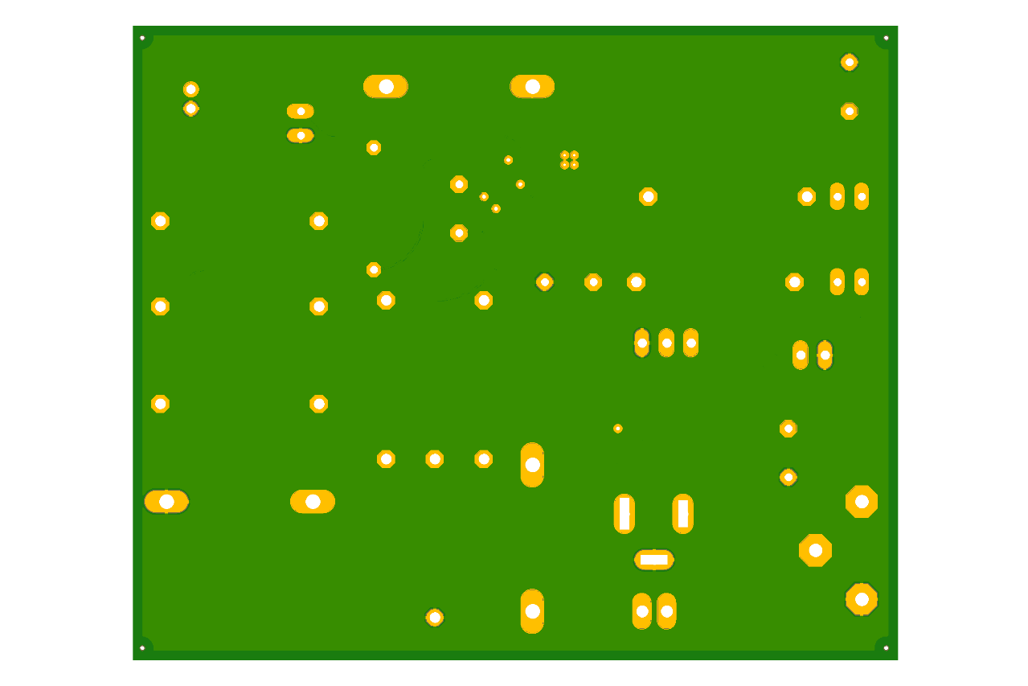

**DRILLS**

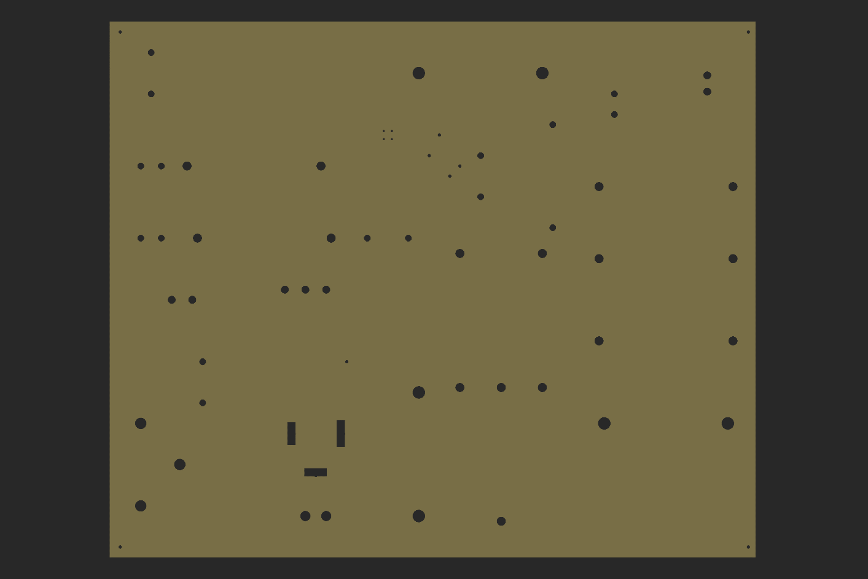

**PCB Layout 2**

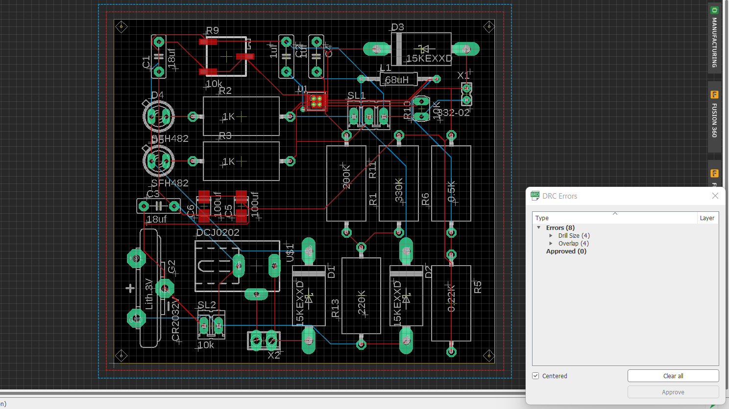

**TOP LAYER BOTTOM LAYER**

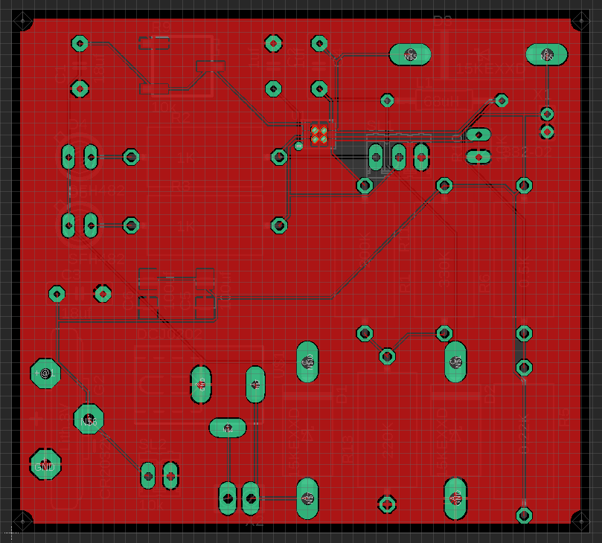

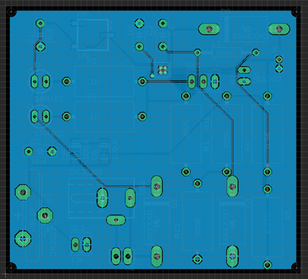

**TOP VIEW**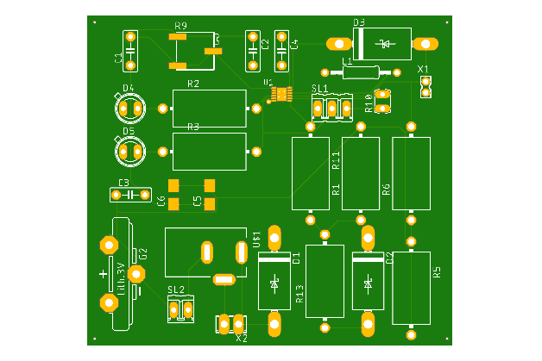

**BOTTOM VIEW**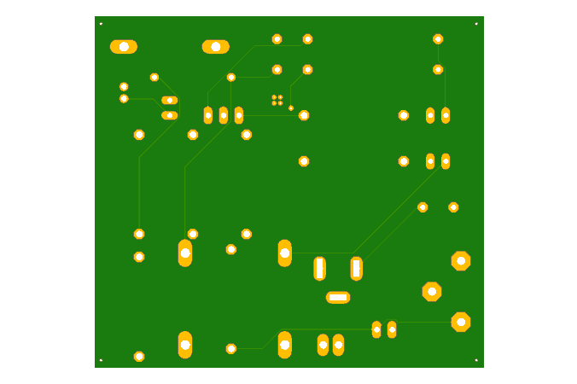

**DRILLS**

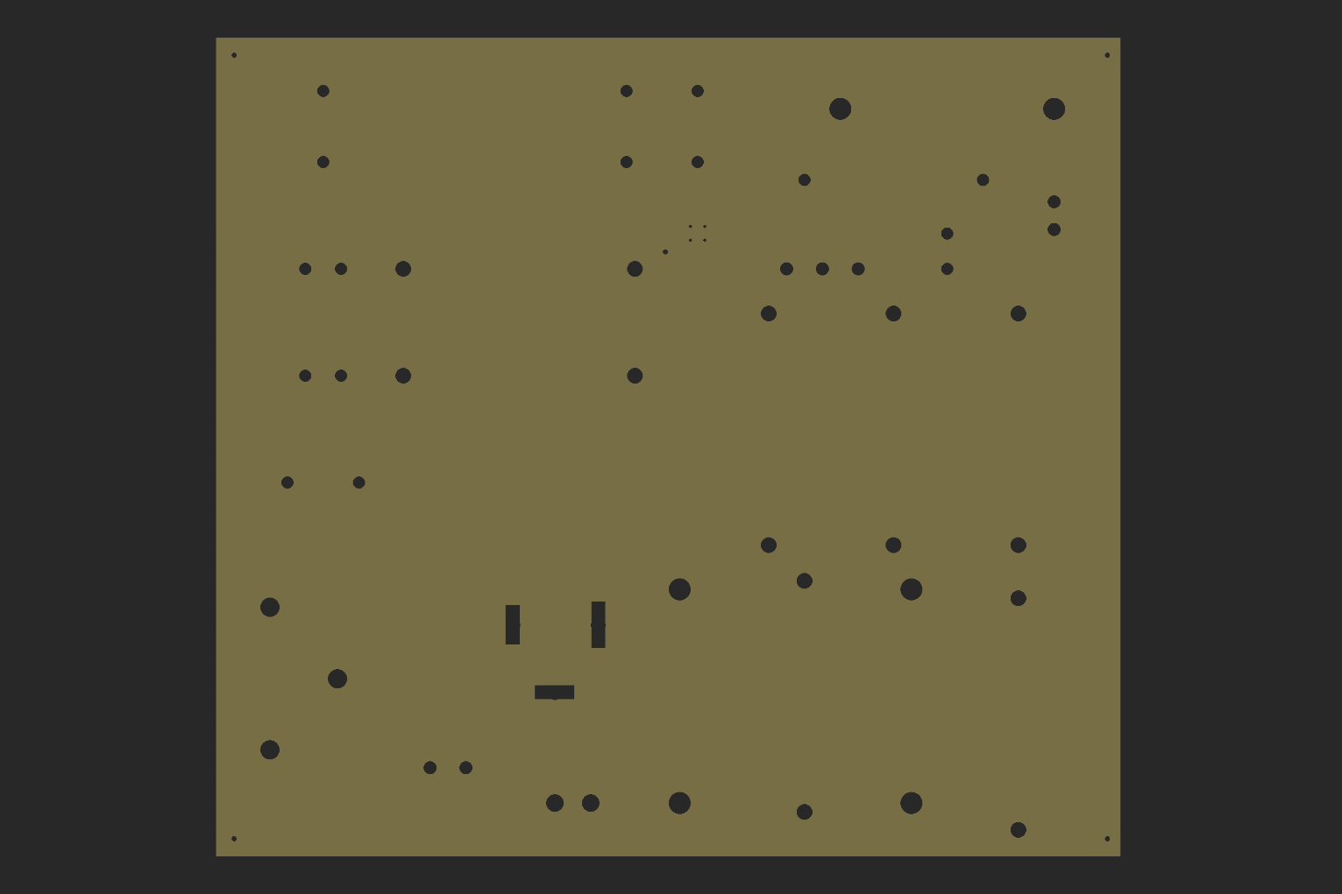

**PCB Layout 3**

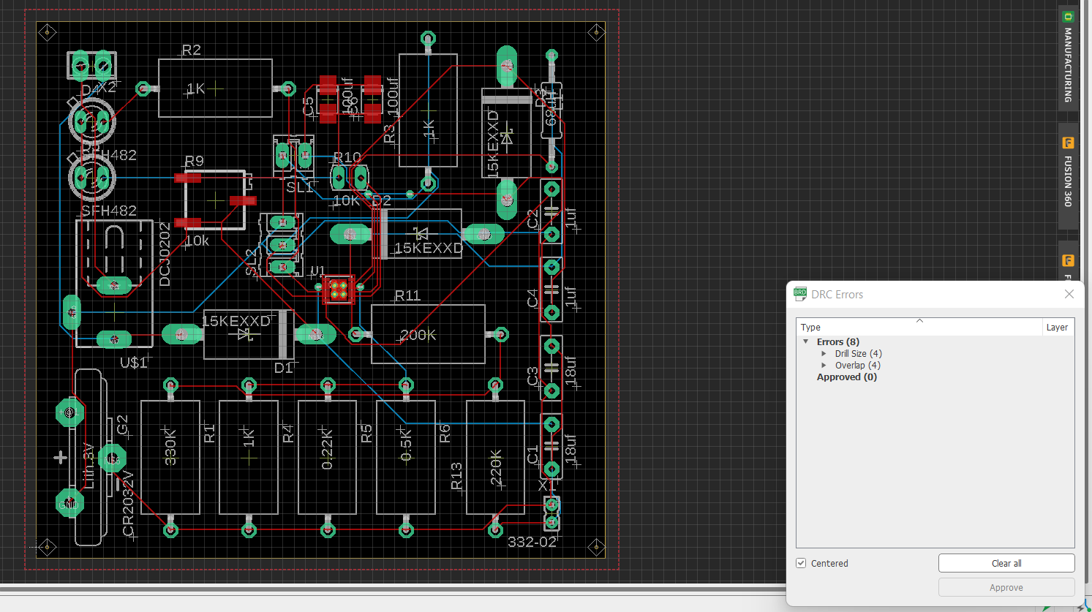

**TOP VIEW BOTTOM VIEW**

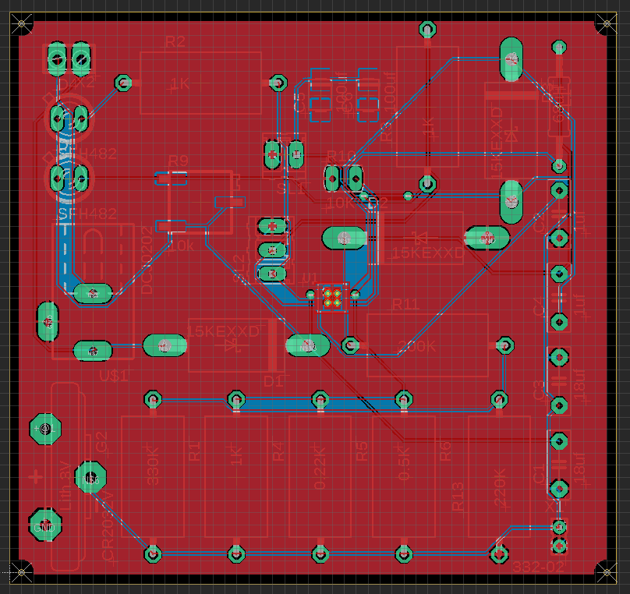

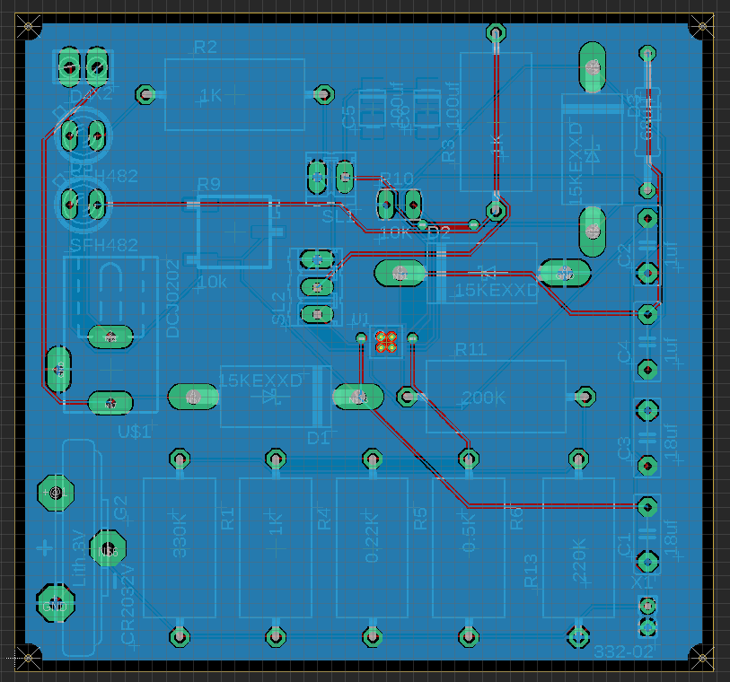

**TOP VIEW**

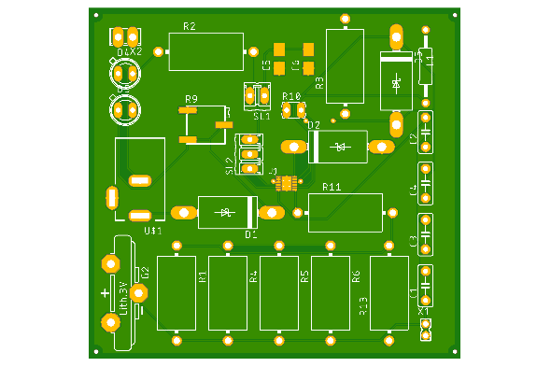

**BOTTOM VIEW**

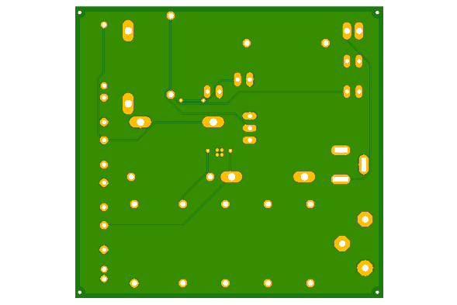

**DRILLS**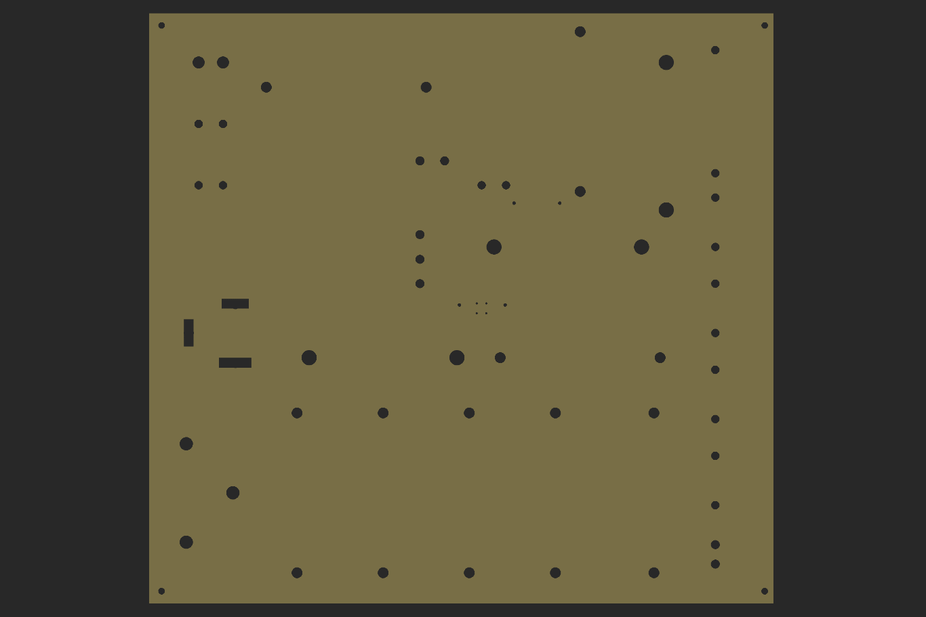

# Challenges faced

* There are 2 type of errors which are faced in the installed library for the LT3652

1.Drill Size x 4

2.Overlap x 4

There eight are from the component LT3652

* We attempted to create the entire PCB on a single layer without using any vias, however the PCB layout had at least one.

# CONTrIBUTIONS:

|  |  |  |
| --- | --- | --- |
| Name | Roll Number | Contribution |
| Gangireddy Sneha Mayi | S20200020261 | schematic and PCB Layout |
| Vudayana Rohith | S20200020313 | schematic and PCB Layout |
| Eaga Jaswanth Krishna | S20200020257 | schematic and PCB Layout |